

**Canterbury Medical Practice News**

**ISSUE 3**

**Summer**



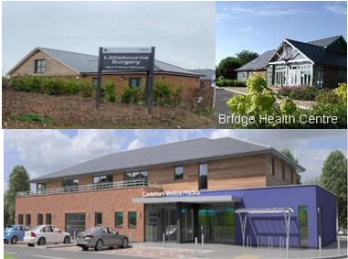

**In this Issue:**

* Pg1 - Welcome
* Pg2 – Surgery updates
* Pg3& 4 – COVID vaccinations
* Pg 5 – National Opt-out
* Pg 6 – PPG
* Pg7 – Staff update

**Bridge Health Centre**

Tel: 01227 831900

**Ethelbert Road Surgery**

Tel: 01227 763377

**Littlebourne Surgery**

Tel: 01227 721515

Dispensary: 01227 721561

Welcome to the Canterbury Medical Practice Newsletter

As many of our patients will now be aware, we moved into our new premises at Ethelbert Road (on the Kent and Canterbury Hospital site) over the weekend of the 20th February. This means that, in addition to the well-established Bridge Health Centre, and the newly built Littlebourne Surgery which opened in 2019, Canterbury Medical Practice now boasts three high quality purpose built centres from which to serve our patients.

**GP Partners:**

Dr Julian Thompson

Dr James Hinksman

Dr Tina Crook

Dr Eddy Rossini

Dr Will Davies

Dr David Gregory

**Salaried GPs:**

Dr Kim Gardner

Dr Alia Faruqui

Dr Kate Peirce

Dr Melissa Russell

Dr Jim Cole

Dr Adrian North

For the full practice team please visit our website:

<https://www.canterburymedicalpractice.nhs.uk/team?category=doctors>

41

The transition to the Ethelbert Road site was remarkably well organised and ran very smoothly, and a big thanks to all involved in this complex and protracted, but ultimately very successful, process! We are now fully established in the new building, and thoroughly enjoying working in such a spacious and modern facility. The feedback from those patients who have visited has been very good, and we look forward to welcoming more of you as restrictions hopefully ease over the coming months.

Many of our patients and staff will have had long associations with Cossington House and London Road surgeries (I had worked at Cossington for over 20 years), so there is some sadness to see them go, but the overall feeling is one of great optimism as we embrace the future from our impressive new home!

*Dr Julian Thompson, Senior Partner, Canterbury Medical Practice*

dd

**Surgery Closures/Out of Hours:**

In the case of urgent need when the practice is closed please call NHS 111. Your needs will be assessed and advice offered or arrangements made to meet a Doctor.

**Upcoming Surgery Closures:**

Please note on the following dates the surgery will be closed from 1pm for staff training:

**Wednesday 14th July**

**Tuesday 7th September**

**Wednesday 13th October**

Upcoming bank holidays:

**Monday 30th August**

**Ethelbert Road Surgery – Now Open.**

Ethelbert Road Surgery opened to the public on Monday 22nd February. We would like to thank the patient participation group and our patients for their continued support of this project.

Canterbury Medical Practice wishes to reassure our patients and confirm that parking at our Ethelbert Road site is free of charge. However, we do require that our patients & visitors using the car park enter their car registration details into the Parking Eye screen adjacent to the reception desk.

If your car registration details are not entered or entered incorrectly a penalty notice will be issued from Parking Eye. However, on providing evidence of your attendance to the Practice we can arrange for the cancelation of any parking fines issued in error.

Please be assured this system has

been put in place for our patients

benefit and to ensure we protect

our parking spaces solely for our

patients use.

Surgery Updates

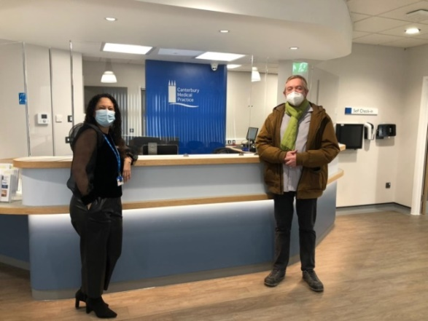



In the last **three months** Canterbury Medical Practice has:

**GPs:**

* Triaged over **1,200** patients for urgent on the day advice
* Seen over **1,300** patients for face-to-face appointments
* Over **5,700** routine telephone calls
* Issued over **7,800** repeat prescriptions
* Visited **160** over patients at home

**Nurses:**

* Over **3,200** nurse appointments have been attended
* Carried out over **2,100** blood tests
* Carried out over **280** blood pressure checks.

**Reception/Admin Team:**

* Processed over **21,000** clinical documents
* Answered over **28,000** phone calls

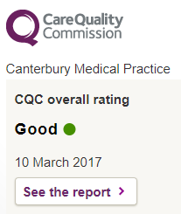

**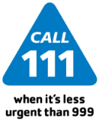**



**Coronavirus Vaccinations Update**

**Ways to access our services**

There are many ways you can contact the surgery apart from the phone. Please see the list below for more information:

**E-Consult**

This is a digital platform that allows patients to seek medical advice or administrative help. It also include self-help information and signposts patients to other services that maybe suitable.

**NHS App**

Is a simple and secure way to access a range of NHS services on your smartphone or tablet. You can book and manage your appointments; order your repeat medication; get health advice and view your medical record.

**Practice Email**

You can always email the practice. For example, to order repeat medication. Please note we can also book appointments via email.

[kmccg.cmp@nhs.net](file:///C:\Users\Dee.stenning\AppData\Local\Microsoft\Windows\INetCache\Content.Outlook\9ML8I58Y\kmccg.cmp@nhs.net)

Our last Phase 1 COVID-19 vaccination clinic at Bridge Health Centre was on Saturday 12th June and as a practice we have reflected over the incredible journey we’ve had over the past six months.

Nobody could anticipate that in December when we commenced the vaccination programme that we would have administered over 19,000 vaccines across the Canterbury South Primary Care Network (PCN).

This would not have happened without the dedication of all our practice team ensuring the clinics were run safely and effectively together with those working behind the scenes booking appointments and liaising with patients.

Canterbury Medical Practice would like say a huge **Thank You** to all of our volunteers who have worked tiredlessly to ensure the clinics run smoothly. Your assistance has been greatly appreciated for the operation of the clinics from individuals (retired GPs and Consultants) administering vaccines to local volunteers from the community.

**Thank you** to members of the Rotary Club for helping us with car park marshalling and checking people in for their appointment and also for kindly donating the gazebo to protect our patients from the adverse weather which was greatly appreciated on those rainy and snowy days!

We chose to deliver Phase1 of the vaccination programme to help protect our local community and those most at risk from the complications of COVID as soon as possible. Phase 2 is being delivered collaboratively with other practices from our central site in Canterbury. In these past six months our workload has increased dramatically with greater demand for access. We appreciate in these times it can be extremely difficult to get through to a member of staff but please be patient as we continue to work hard to meet demand.

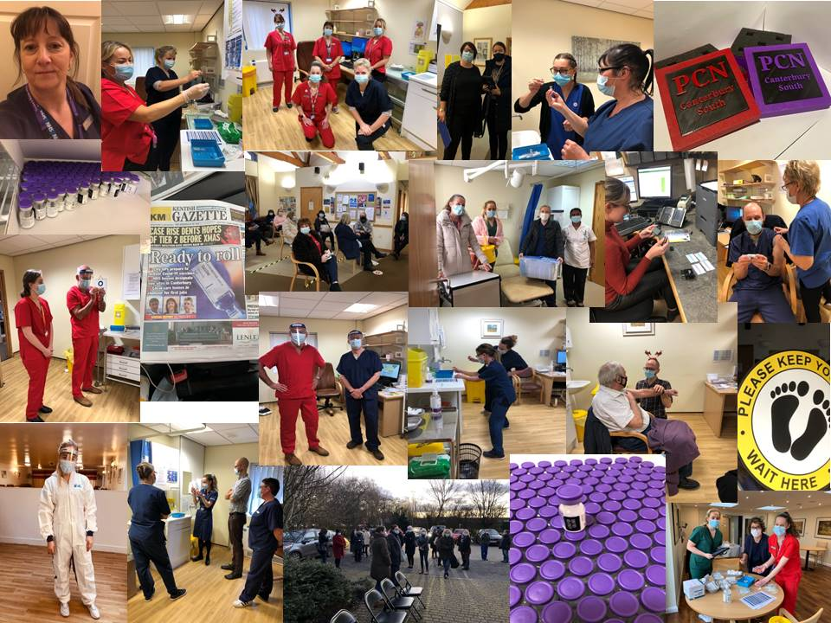

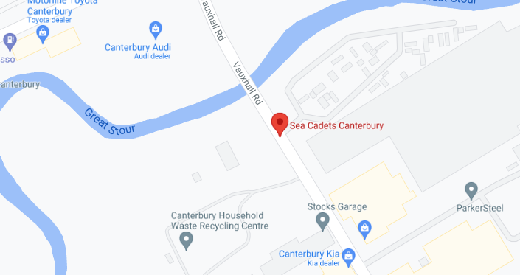

If you do not have access to a smartphone or tablet and you know that the country is travelling to requires COVID-19 vaccination status you can call the NHS helpline 119 and ask for a letter to be posted to you. Please note this must be 5 days after you’ve completed your course of the vaccine. The letter could take **up to five days** to reach you.

For more information please visit: [https://www.gov.uk/guidance/demonstrating-your-covid-19-vaccination-status-when-travelling-abroad](https://www.gov.uk/guidance/demonstrating-your-covid-19-vaccination-status-when-travelling-abroad%C2%A0)

**How to access your COVID-19 vaccination status:**

Please **do not** contact the surgery to obtain your COVID-19 vaccination status as the GPs cannot provide letters to show your status.

You can access your COVID-19 vaccination status by downloading the free NHS app which can be accessed via smartphones or tablets.

**1st COVID-19 Vaccinations:**

As of 6th May we are no longer offering our patients their first COVID vaccination to those under the age of 50 as we are currently working with all Canterbury practices at a more central site.

This site is **The Sea Cadet Hall at Vauxhall Road**, Canterbury CT1 1ZN.

You can **now** book your appointment is you are aged 18 or over.

To book your appointment please visit: <https://www.nhs.uk/conditions/coronavirus-covid-19/coronavirus-vaccination/book-coronavirus-vaccination/>

**Business as usual**

Although our doors are currently closed as per Government guidelines. Please rest assured we are still open. If you have any medical concerns, please do not hesitate to ring the surgery. Whilst, we are not currently offering routine face-to-face appointments if a Doctor feels you need to be seen they will triage you over the phone and invite you into the practice if deemed appropriate.

If the surgery if closed please ring **NHS 111** or if it life threatening please ring **999**.

**Register your Type 1 Opt-out Preference**

The data held In your GP medical records is shared with other healthcare professionals for the purposes of your individual care. It is also shared with other organisations to support health and care planning and research. If you do not want your personally identifiable patient data to be shared outside of your GP practice for purposes except your own care you will need to register your choice with the surgery using the following [form](file:///\\emis12333a\bridge$\VickiC\Register%20your%20Type%201%20Optout%20preference.docx).

For more information please visit: <https://www.nhs.uk/your-nhs-data-matters/>

**Social PrescribingTeam Update:**

The role of a Social Prescriber Link Worker is to provide support to individuals, their families and carers to take control of their health and wellbeing.To live as indepdent as they can and to improve health outcomes. To take on a holistic approach, by giving people time and focus on :

**“What matters to me.”**

Active caseload (*figures from between Jan- beginning of March*):

**Total Active Caseload: 128**

* Canterbury Health Centre: 9
* Canterbury Medical Practice: 59
* New Dover Road: 8
* Northgate: 40
* Old School Surgery: 0
* Sturry Medical Practice: 12
* University Medical Practice: 2

**L-R :***Clare Turner – Patient Care Co-ordinator; Debbie Williams – Social Prescribing Link Worker; Pippa Hilary Care Home Co-ordinator & Nicola Cloughley – Social Prescribign Link Worker*





**Health & Wellbeing Useful Contacts :**

**Asthma Uk: Advice on inhaler technique:**

[**https://www.asthma.org.uk/advice/inhaler-videos/**](https://www.asthma.org.uk/advice/inhaler-videos/) **Asthma Uk: What to do in an asthma attack:**[**https://www.asthma.org.uk/advice/asthma-attacks/**](https://www.asthma.org.uk/advice/asthma-attacks/) **GOV UK : COVID-19 Stay-at-home guidance :**

[**https:// www.gov.uk/government/publications/covid-19-stay-at-home-guidance**](https://www.gov.uk/government/publications/covid-19-stay-at-home-guidance) **GOV UK: Get a COVID-19 test :** [**https://www.gov.uk/get-coronavirus-test**](https://www.gov.uk/get-coronavirus-test) **Healthier Together: Information for under 18s**

[**https://what0-18.nhs.uk/professionals/gp-primary-care-staff**](https://what0-18.nhs.uk/professionals/gp-primary-care-staff) **NHS UK: Coronavirus info & advice**

[**https://www.nhs.uk/conditions/coronavirus-covid-19/**](https://www.nhs.uk/conditions/coronavirus-covid-19/) **NHS UK: Get an isolation note**[**https://111.nhs.uk/isolation-note/**](https://111.nhs.uk/isolation-note/) **NHS UK : Mental health support with COVID-19**

[**https://www.nhs.uk/oneyou/ev ery-mind-matters/**](https://www.nhs.uk/oneyou/every-mind-matters/) **NHS UK: Your COVID-19 recovery guide**

[**https://www.yourcovidrecovery.nhs.uk/**](https://www.yourcovidrecovery.nhs.uk/) **NHS Volunteer Responders: Services**[**https://nhsvolunteerresponders.org.uk/services**](https://nhsvolunteerresponders.org.uk/services) **RCOG UK: Coronavirus infection & pregnancy**

[**https://www.rcog.org.uk/en/guidelines-research-services/guidelines/coronavirus-pregnancy/covid-19-virus-infection-and-pregnancy/**](https://www.rcog.org.uk/en/guidelines-research-services/guidelines/coronavirus-pregnancy/covid-19-virus-infection-and-pregnancy/) **RCOT UK: Managing post-viral fatigue after Covid-19**

[**https://www.rcot.co.uk/recovering-covid-19-post-viral-fatigu e-and-conserving-energy**](https://www.rcot.co.uk/recovering-covid-19-post-viral-fatigue-and-conserving-energy)

**Patient Participation Group (PPG)**

The Practice has a Patient Group whose membership comprises of patients from Bridge Health Centre, Littlebourne and Ethelbert Road surgeries. The group meets three times a year and the aim is that by working together we can continue to develop and improve the services we are able to offer patients.

**What can you do as a member of the PPG?**

* Assist in finding out the views of patients about their healthcare needs and future developments.
* Provide feedback to healthcare professionals with the primary healthcare team to improve health and well-being.
* Increase patient & user’s sense of involvement in their healthcare.
* Help to demonstrate the Practice’s commitment to patients.

If you are interested in joining,please complete the sign-up form: <https://www.canterburymedicalpractice.nhs.uk/patient-participation-group>

From Saturday 3rd July at the Red Lion pub in Bridge there is a computer course run by one of our Patient Particicpation Group members and all patients are welcome.

**Patient Participation Group (PPG)**

The members of the PPG provide a voice on behalf of the population registered at the practice. Also by working collaboratively with the practice to improve services for patients.

The group meets three times a year and comprises of patients from Bridge Health Centre, Littlebourne & Ethelbert Road. If you would like to sign up to the Patient participation Group please visit our website.The next virtual meeting is **Thursday 8th July.**

If you would like to view all the minutes from the previous meetings, please visit:

<https://www.canterburymedicalpractice.nhs.uk/patient-group-meeting-minutes>



**VeryConnect**

As of 1st February 2021 a online community platform has been launched known as VeryConnect. It provides members with a unique space to connect, network, learn from one another and access opportunites.

You will be able to submit articles and share them with people in your membership. You will also be able to post news and social media items to promote the activities of your patient participation group. Lastly, you will be able to post questions, ideas or thoughts on a wide variety of topics which will enable other patient participation groups to engage and respond.

**Staff Update:**

Canterbury Medical Practice would like to welcome Charlotte & Sandra who have both joined our reception team recently.

Dr Adebaoya Mapayi has joined the practice as a registrar (ST2)C:\Program Files (x86)\Microsoft Office\MEDIA\OFFICE14\Lines\BD21448_.gif

Lastly please join us in wishing the staff listed below good luck and best wishes in their future endeavours:

Alfie (Receptionist)

Lucy (Dispenser)

At the end of July Dr Davies & Dr North will be leaving the practice.

For more information please visit: [https:/ /www.veryconnect.com/](https://www.veryconnect.com/)